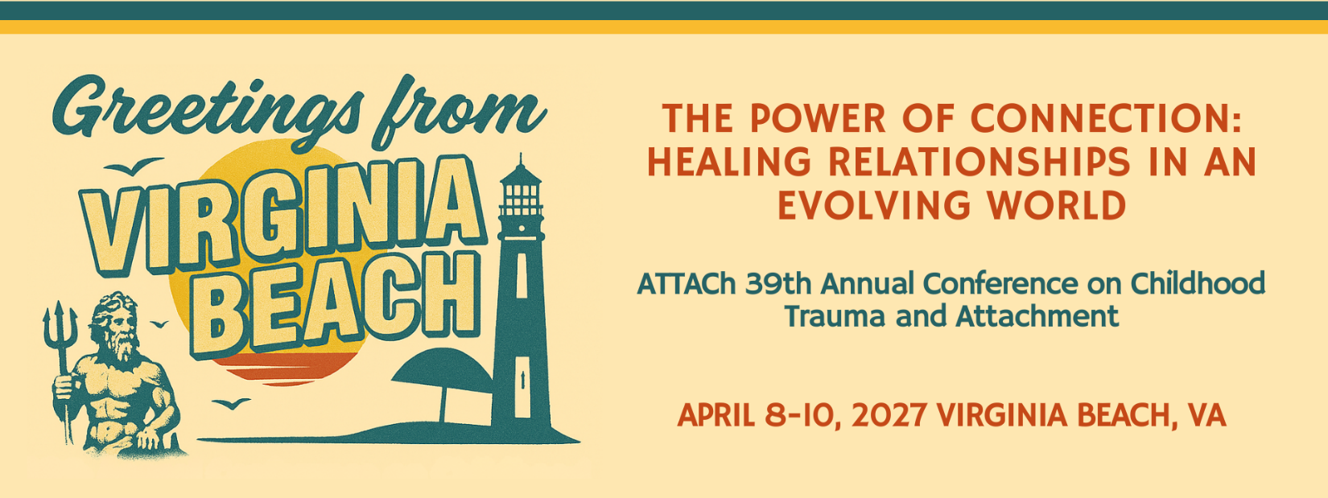2027 Conference Marketing Toolkit

HOW TO GET STARTED
Follow the Conference on our social channels and join the conversation.
- Facebook - https://www.facebook.com/ATTAChOrg/
- Instagram - https://www.instagram.com/attach_org/
- LinkedIn - https://www.linkedin.com/company/attachorg/
- Use the conference hashtag #ATTAChVirginiaBeach2027 in all your posts so we can easily find and share them
- Tag @attachorg and on IG only @attach_org in all your posts so they appear in our accounts.
- Share the event website link (2027 ATTACh Conference - ATTACh) in your posts and encourage your colleagues/followers to book their hotel and conference registration at 2027 ATTACh Conference - ATTACh.
BEFORE THE CONFERENCE: Promotion beforehand gets the word out so people can plan to attend our conference! If we begin promoting NOW, people have enough time to book flights, hotels, and save!
- Post about your participation on your social channels.
- Post related content to generate interest and to position your organization as leaders in the industry.
- Share videos, articles, research, statistics, infographics, etc.
- Share ATTACh Conference posts promoting the event – find them by searching the hashtag #ATTAChVirginiaBeach2027
DURING THE CONFERENCE: Post your thoughts and experiences from the event.
- Follow the #ATTAChVirginiaBeach2027 hashtag on social media to see what other attendees are saying and to join the conversation.
- Post quotes from speakers or your thoughts on their presentations.
- Share a photo of you watching the conference or at the conference.
AFTER THE CONFERENCE: Reinforce your organization’s position as an industry leader.
- Post your key takeaways from the event.
- Which presentation did you enjoy the most at #ATTAChVirginiaBeach2027 and why?
- How will you apply what you learned at #ATTAChVirigniaBeach 2027 in your work as an industry leader?
- Connect with other attendees and build your professional network.
Links/Letters/Script Shortcuts
Main Conference Page   | Parent Scholarship  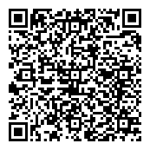
ATTACh Membership   | Hotel Registration  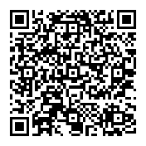
Sponsorship, Exhibitor & Program Ad Info   | Contact Us  
Silent Auction Donation
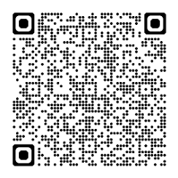

- Solicitation Letters (3) - https://attach.org/conference-letters-2027/

#1: SOLICITATION LETTER (SPONSOR, ADVERTISER OR SCHOLARSHIP PROVIDER)
#2: INVITATION LETTER (ORGANIZATIONS/AGENCIES)
#3: INVITATION LETTER (PARENTS/CAREGIVERS)

- Video Script (30 second video)
Hi, I’m _____________ with _______________and I’m excited to invite you to ATTACh 39th Annual Childhood Trauma and Attachment Conference in Virginia Beach, VA, April 8th – 10th, 2027. We have so many great workshops for professionals and caregivers.
Include your own reason(s) this conference is important and why professionals, parents, and/or youth/young people should attend.
To learn more about the conference and how you can attend, visit the 2027 Conference link on the ATTACh website.

Upcoming Parent and Professional Trainings - https://attach.org/training/

Social Media Messages/Graphics

Conference Social Media Hashtags - #ATTAChVirginiaBeach2027
Conference Social Media Posts - See sample messages below. You may edit and/or create your own!
Copy and share them with your social media networks to help promote the conference.
- JOIN ME: ATTACh 39th Annual Childhood Trauma and Attachment Conference in Virginia Beach, VA April 8-10, 2027! I'm excited to attend a session with keynote speaker George Thompson! Learn more & register: 2027 ATTACh Conference - ATTACh #ATTAChVirginiaBeach2027

- Ready to make Powerful Healing Connections? Join me for the ATTACh 39th Annual Childhood Trauma and Attachment Conference in Virginia Beach, VA April 8-10, 2027! Advance your knowledge & understanding. discover expert trainers, speakers + strategic partners, find support. Explore the event: 2027 ATTACh Conference - ATTACh #ATTAChVirginiaBeach2027

- We are excited to be a sponsor at the ATTACh 39th Annual Childhood Trauma and Attachment Conference in Virginia Beach, VA April 8-10, 2027! Grab your spot here: 2027 ATTACh Conference - ATTACh #ATTACh VirginiaBeach2027

- We look forward to attending ATTACh 39th Annual Childhood Trauma and Attachment Conference in Virginia Beach, VA April 8-10, 2027! Will you join us? 2027 ATTACh Conference - ATTACh #ATTAChVirginiaBeach2027

- Join us for three days (April 8 – 10, 2027) of networking, presentations, conversation and discussion about healing childhood trauma and attachment in children of every age. This year, the 39th Annual Childhood Trauma and Attachment Conference has 7 tracks to choose from with something for everyone! - 2027 ATTACh Conference - ATTACh #ATTAChVirginiaBeach2027
- Don’t miss this opportunity to hear the latest research, trends, and strategies at the 39th Annual Childhood Trauma and Attachment Conference April 8 – 10, 2027. 2027 ATTACh Conference - ATTACh
#ATTAChVirginiaBeach2027
- Check out the world-class keynote speaker lineup, expert-led training workshops and networking gatherings all happening at the 39th Annual Childhood Trauma and Attachment Conference in Virginia Beach, VA April 8-10, 2027! Find out more at 2027 ATTACh Conference - ATTACh #ATTAChVirginiaBeach2027
LOGO-
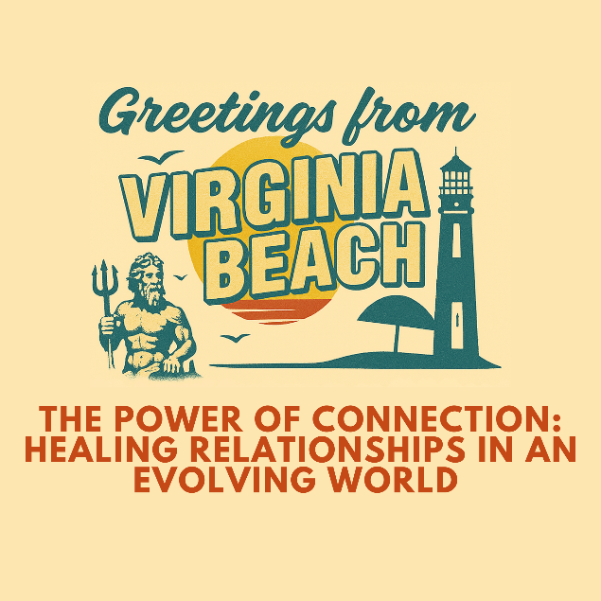
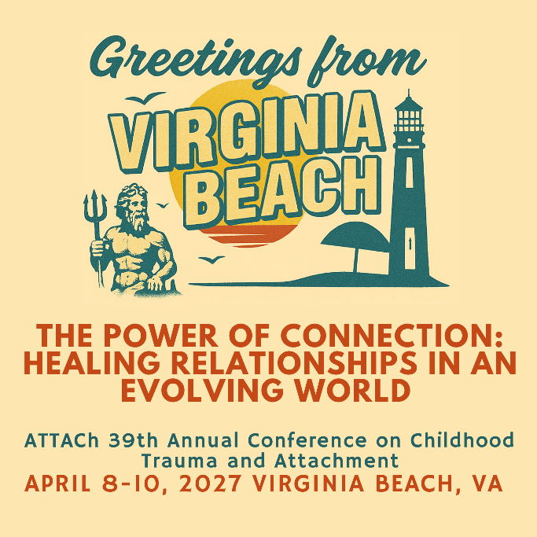
HEADER-
Email Signature Logo & Link
(To download, select image. Right click and select "Save Image As" to save a copy in your files. Images are resizable.)

2027 Conference Link: 2027 ATTACh Conference - ATTACh

As part of the Conference Committee, I’d love to invite you to attend the 39th Annual Childhood Trauma & Attachment Conference! Learn alongside other professionals and parents in over 40 world class workshops across 7 tracks on attachment, trauma, and related topics.

